**NAME: MAHBOOB ALI**

**ID NO: BIT-24S-027**

# LAB 01

**INTRODUCTION TO PYTHON:**

Python is a beginner-friendly programming language that's easy to learn and use. It’s popular because it has simple, readable code and can be used for many things, like building websites, analyzing data, or creating games. Python works on all major operating systems, like Windows and Mac, and it has many built-in tools (called libraries) to make your work easier.

TASK NO 1: Make 2-2 programs of each datatype**.**

1. **NUMERIC TYPES**

**Integer (int)**

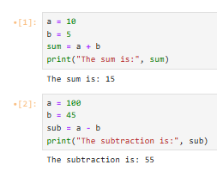



**Floating-point (float)**

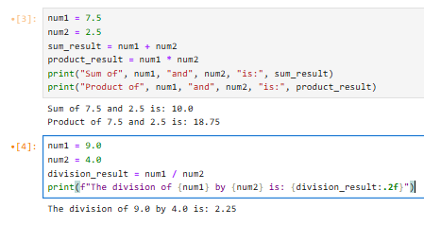

**Complex (complex)**

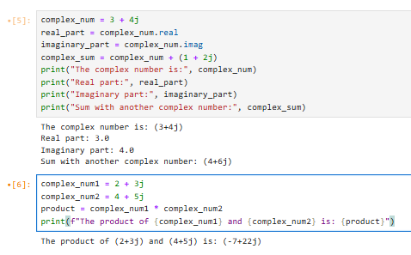

1. **Sequence Types**

**String (str)**

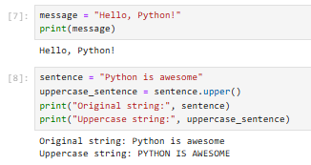

**List (list)**

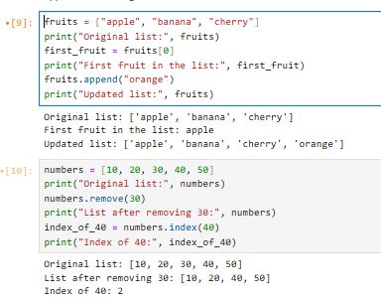

**Tuple (tuple)**

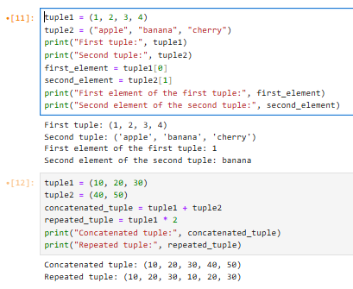

**Range (range)**

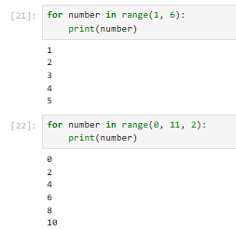

**3. SET TYPES**

**Set (set)**

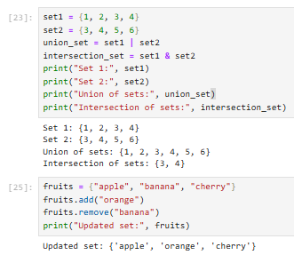

**Frozen Set (frozenset)**

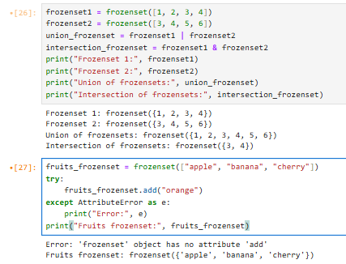

1. **MAPPING TYPE**

**Dictionary (dict)**

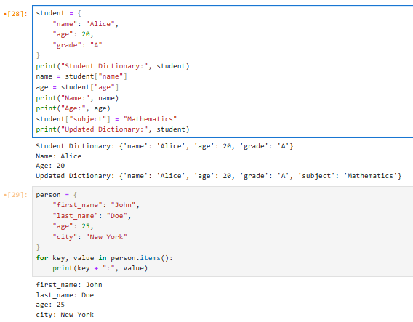

1. **Boolean Type**

**Boolean (bool)**

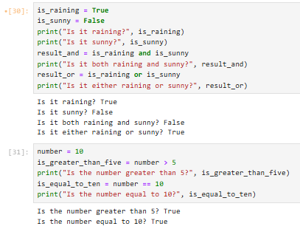

**TASK NO 2: Make up to 5 Shape programs using *.**

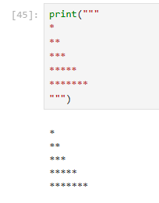

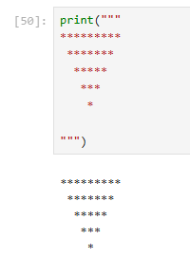

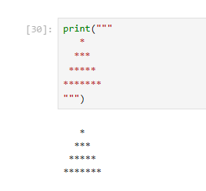

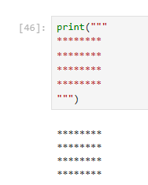

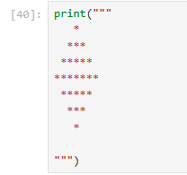

**TASK NO 3: Make same shapes you have made in task 2, using multiple by number.**

